**Classification of neurons and their function in biological networks**

**Applied Data Science Course**

Interdisciplinary efforts are invested in studying the function and connectivity of the brain. The brain is a complex organ consisting of many types of cells. The major building blocks of the nervous system are the neurons (nerve cells), organized in interconnected networks, and transmit information by electrochemical signaling via action potentials and neurotransmitters (Fig 1).

A B

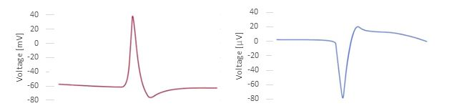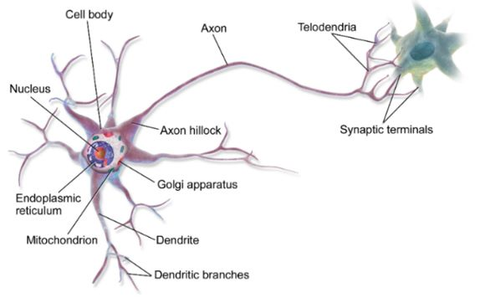

**Figure 1:** Description of a neuron cell.(A) Scheme of a typical neuron's morphology (B) Action potential signal of a neuron.

A neuron could be either excited or inhibited, dependent on the received neurotransmitter. A neurotransmitter is a signaling molecule secreted by a neuron to affect another cell across a synapse (the junction through which neurons' signals can be sent to each other) (Fig 2). Common neurotransmitters include glutamate, GABA, acetylcholine, glycine, and norepinephrine. Understanding complex brain processes requires the analysis of neuronal activity recordings. Here, we suggest distinguishing between different types of neurons based on their electrical signal characteristics.

**Figure 2:** Structure of a typical chemical synapse.

We will work on data from electrical activity recordings of mice cortical neurons. The data was taken from the ["Allen cell type"](https://celltypes.brain-map.org/data?donor__species=Mus%20musculus) site. The given raw data is of voltage as a function of time. It was edited into tabular data by Ofek Ophir (an MSc student in Orit Shefi's and Ofir Lindenbaum's labs at Bar Ilan University) based on characteristics of the electrical activity such as signal amplitude, frequency, signal duration, cell source, cell type, etc. The dataset has 1425 observations from different cells and 46 columns (45 features and the "neurotransmitter" column serves as labeling).

We will use the data to classify neuron type- GABAergic/ Glutamatergic, i.e., inhibitory/excitatory, respectively, which indicates the function of the cell in the biological network. In the first stage, we will perform EDA to visualize and deepen our understanding of the data. We will look after some trends and correlations between some features and organize the data conveniently for our analysis. We will examine more interesting patterns in the data based on the insights raised from the EDA.

We will use two ML approaches:

1. Supervised learning to learn the data and predict the most relevant label of a given neuron. Currently, we aim to predict the neuron type as mentioned above. However, it is flexible.
2. Unsupervised learning to learn patterns in the data and figure out some available clustering options of the neurons or detect anomalies.

Successful classification and prediction of neurons into distinct types based on their electrical activity patterns could potentially enable us, in the future, to detect neurons as either healthy or diseased. With appropriate data, this approach could also be expanded to the diagnostic of diseased areas in the whole brain.